REAUX LABS (ADMIN)

- There is no option to add membership details(amount, due date) and more details like (monthly/quterly/annually) for new customer. It needs to be added in this page while adding new customer.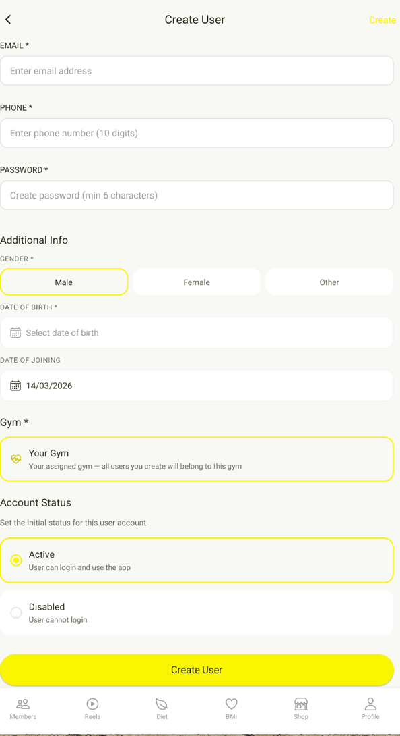

- Fee is completely paid but still showing due amount as 0 plus there is no upcoming date shown for fees, so how we got to know like on which day the fees is pending. Also please make sure the names will be filtered out automatically with context to due dates.
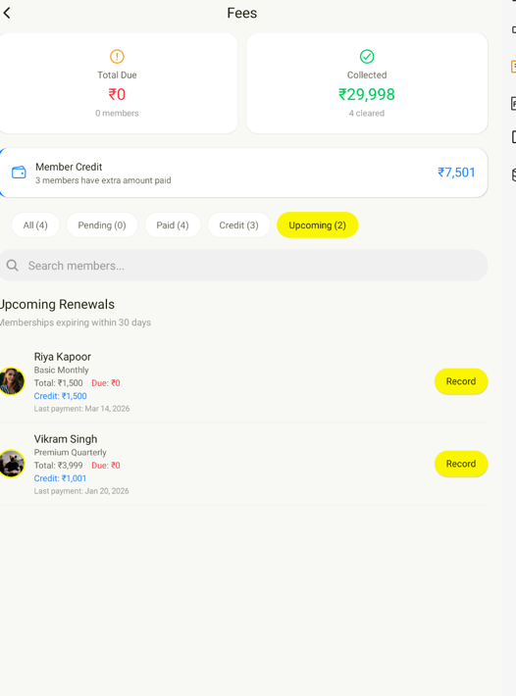

- Also there is no payment history shown anywhere except last payment date. We need all payment history individually shown while clicked on that person’s name.
- We need all details like payment history, due date, advance payment in this page as well. So that it will be easy to understand and simplified for admin. 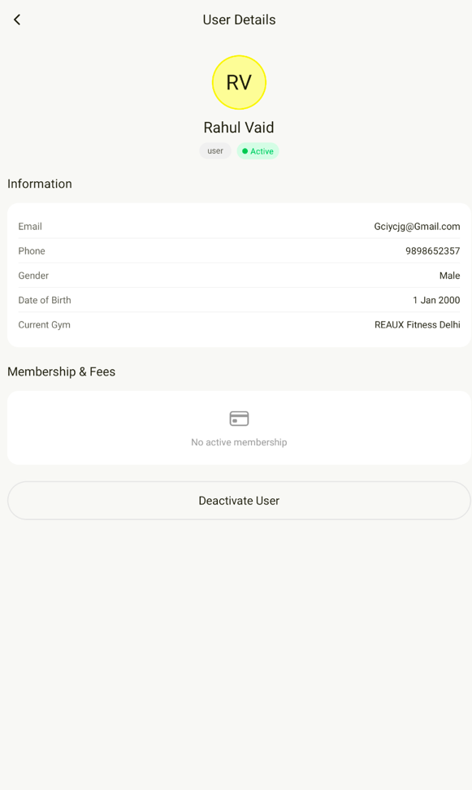
- While posting comments on the post section, everything including author’s profile image and name is getting refreshed.(blinking with each character being typed)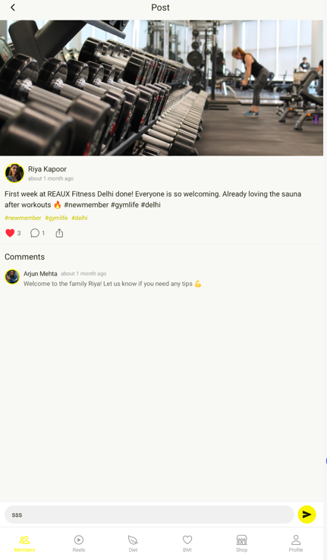
- There is no pop-up for notification.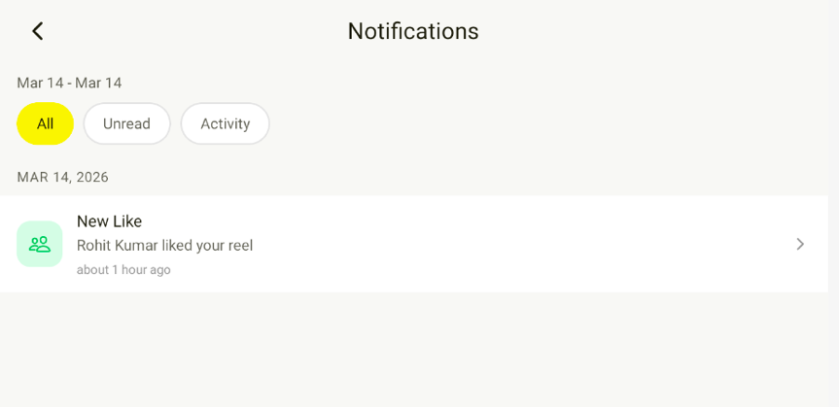
- There are some comments on some reels but there is no count under that. Please insert comment counts.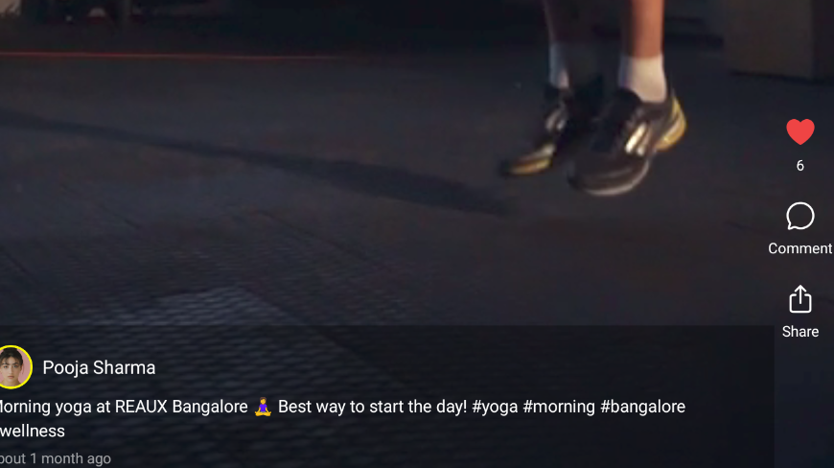
- Dropdown menu in needed for city and state in address. Also limit phone number to 10 digits in address. Right now we can put random numbers in that.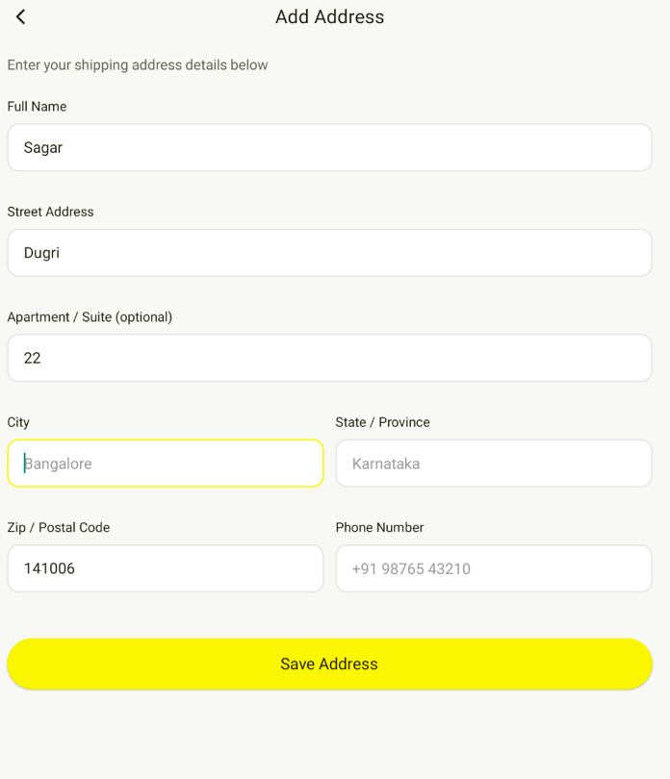
- While sharing anything this notification is showing, instead of this or addition to this if we can share link of our app from playstore/Appstore after launch and Instagram link before launch.
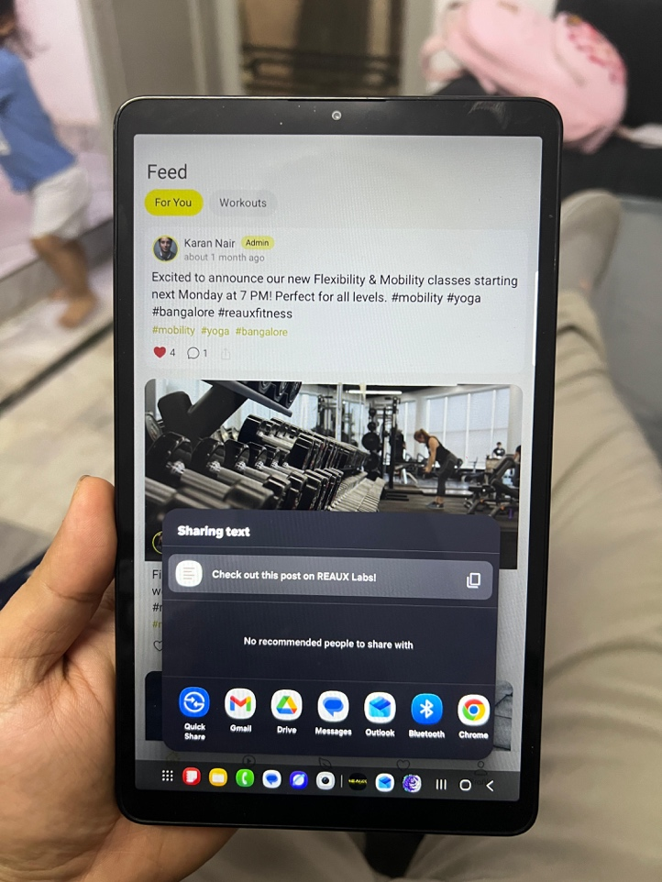
- We want reels to be refreshed every time a person opens the app or swiping down from the top like Instagram and other apps.
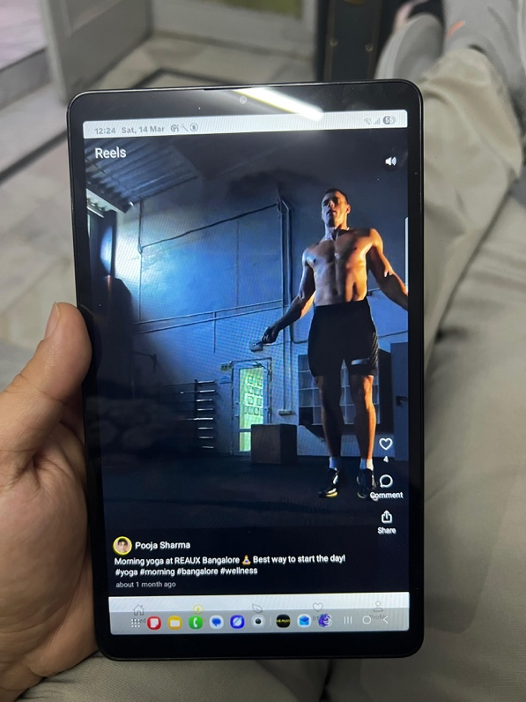
- Please add additional open of saved addresses for ease of adding multiple address in same account.
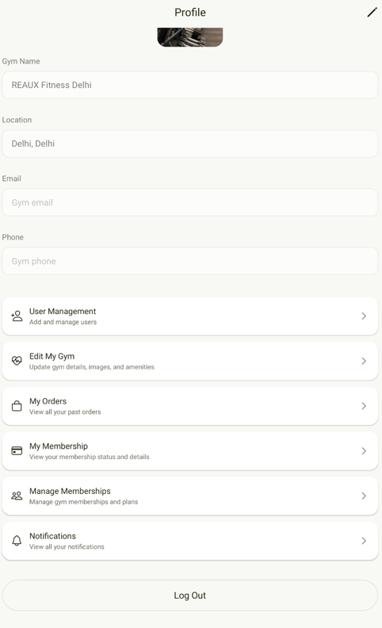
SUPER ADMIN
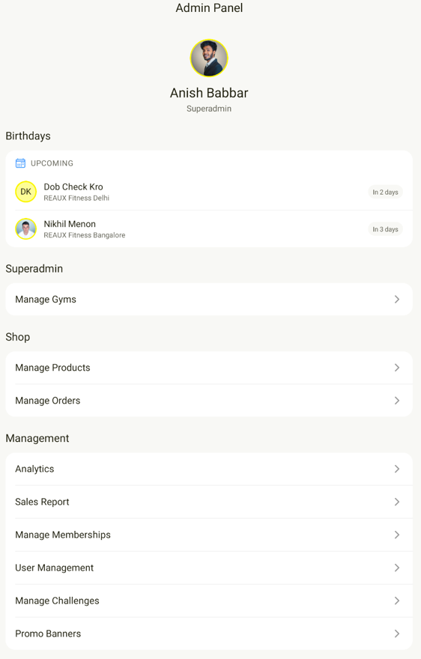
- Sales report needs to be moved up in shop section
- Please move the whole shop section with 3 sub headings ( Manage Products, Manage Orders, and sales report (mentioned in point 12.) outside in main profile section instead of my membership and my orders. These 2 sections are not for super admin as we are not going to place any order or buy any memberships.
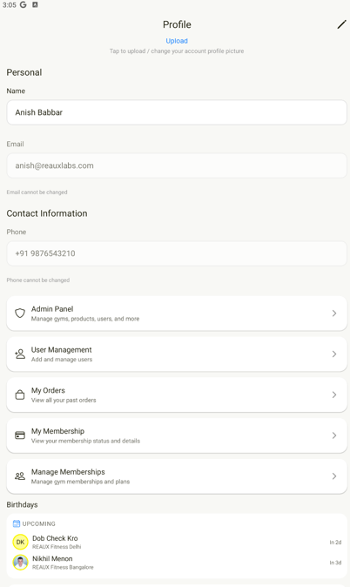
- As mentioned in previous meeting, we need details of members gym wise. For instance, if I click on Karan (admin) as super admin, we can see details of every person in his gym under his name also. Additionally, we can also export that list as pdf.
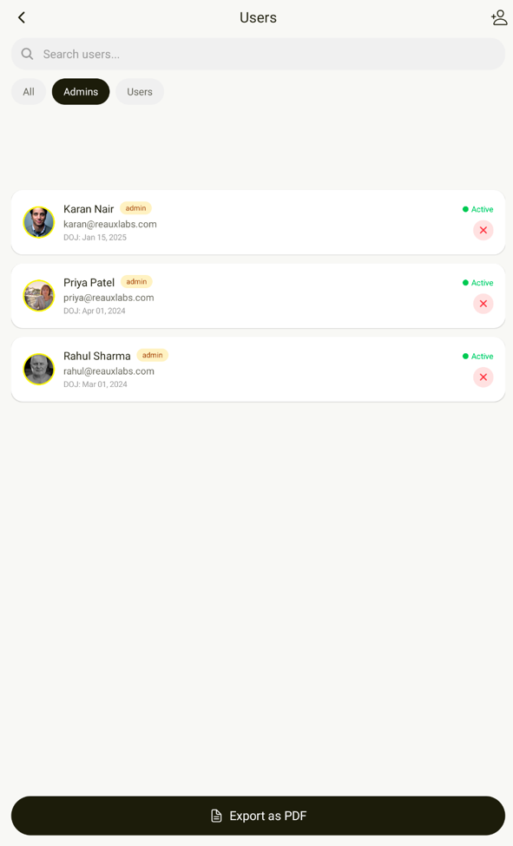

- Please add contact us section in all (Super Admin, admin and user).

